Arlington Cooperation Foundation

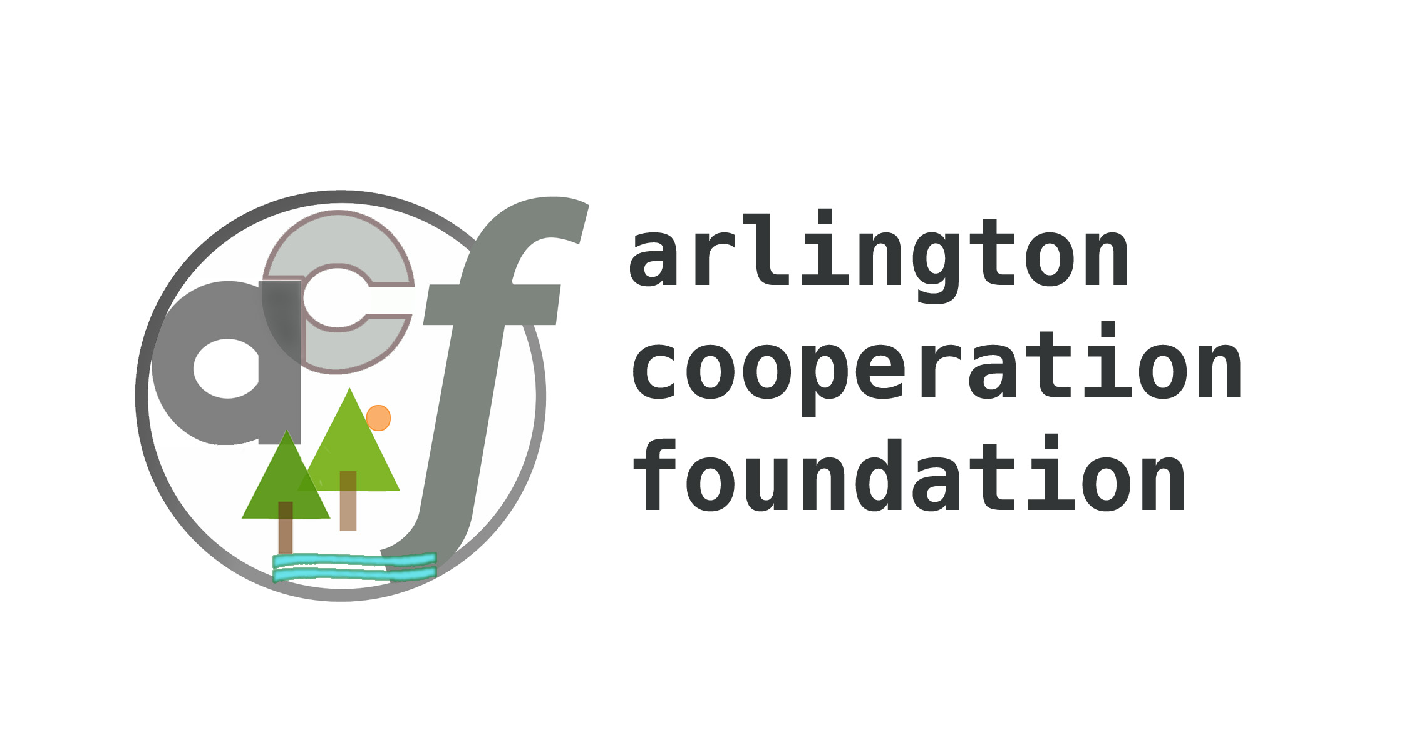

611 South Ivy Street ● Arlington Virginia 22204

racedirector@marathoncharitypartners.org ● 703-927-4833 ● www.marathoncharitypartners.org/acf ● proudly presents
Abebe Bikila Day
International Peace Half-Marathon
Monday, September 1, 2008

Welcome to Abebe Bikila Day International Peace Half-Marathon. Today, we encourage competition on the playing field of peace as we welcome runners from all over the world. Sport is an international language, along with Art, Math, Music, and Science. Abebe Bikila’s historic wins at the 1960 and 1964 Olympic Marathons inspired a world of runners.

Our race benefits ACF's Marathon Charity Partners: AIMS India Foundation • American Red Cross - Prince William • Association for India's Development • Asha for Education • Big Brothers/Big Sisters of the National Capital Area • Cystic Fibrosis Foundation • 5th Pillar • High Cloud Foundation • Hope for Humanity • Iqraa (Read) • Stop the Silence: Stop Child Sexual Abuse -- PLUS • Building Tomorrow • Hope Runs • Ethiopian Community Development Council.

We thank our sponsors: Pacers Running Stores • Addis Restaurant (Oakland CA) • American General Supplies, Inc. (AGS) • Atlantic Services Group Inc. • Bruegger's Baked Fresh • Cabot Creamery Cooperative • Dama Restaurant • EliasNegash.com • Ethiopian Sport News • Mesfin Getachew • Gold's Gym • Great Harvest Bread Co. • Honest Tea • Mark Computing and Accounting Firm • Pacers Running Stores • Coach Anne Pastorkovich • Radio Abyssinia • Starbucks • Tenadam International Market • Whole Foods of Old Town • Zelalem Injera

The half-marathon course:
← Half-marathon finish line
} 97.5 meters
←Half-marathon start line
} 10,500.0 meters
Down and back
=21,000.0 meters
←Half-marathon turnaround
- Starts on the grass east of the bathroom at Belle Haven Park
- Run 10.5km south. Turn around at Riverside Park. Run 10.5km back north
- Pass the start and finish 97.5m north, at the picnic area, for a total of 21.0975km
- Half-marathon starts at 9:00 am. Children’s one-mile starts at 9:05 am
- Please wear your bib number visibly in front

Individual Scoring:
- Pick up your timing tag on Monday only. Affix it firmly to your shoe using twist-ties, safety pins, or shoelaces
- Race starts at 9:00 am. Per USATF rules, scoring is based on finish times, but we also record and report net times
- $250, $150, $100, to top three males and females
- Gift certificates from Pacers Running Stores for top 1-2-3 in 10-year age groups, male and female
- We present awards as soon as possible after the race
- We post results on www.marathoncharitypartners.org/bikila Monday night and e-mail them to all participants
- Please inspect your bib number. It shows your name, gender, age as of race day, city, and citizenship
- Please inform us of any corrections before the race.

Team Scoring:
- Teams are for pride, not prizes. We total the points of each state or nation, top 3 count
- 1st place in the half marathon wins 1 point, 2nd place wins 2 points, 3rd place earns 3 points
- Play fair – no changing citizenships in the middle of the race
- Don’t disappoint your team – you might be the finisher your team needs to have bragging rights for an entire year!

Sunday, August 31:
- 2:00 to 5:00 pm – Pre-race packet pickup at Pacers Running Store, 1301 King St, Alexandria VA, 703-836-1463
- Pick up your bib number, goodie bag, and performance jersey – a unique t-shirt you will enjoy wearing
Your goodie bag contains information, this letter and course map, literature and, and coupons

Monday, September 1:
- 8:00 am – Registration opens at Belle Haven. Pick up your timing tag, bib number, goodie bag, and t-shirt
- 9:00 am – Competitive half-marathon start -- 9:05 am – Non-competitive children’s one-mile start
- 10:00 am - 12:00 noon – Medals by Dan Kain Trophies; picnic by Bruegger’s Baked Fresh, Cabot Creamery Coop, Great Harvest Bread, Whole Foods Market Old Town, and Zelalem Injera
- Around 11:00 am – Half-Marathon awards
Permanent bathrooms are located at Belle Haven Park and Riverside Park. Water, Gatorade, and course marshals are at 10 locations staffed by charity teams: 13.1 
A. Belle Haven  Start 13.0 ☺ ♀♂
Belle Haven Park has limited parking.
We promised to leave some spaces open for picnickers. Please do not park on the grass or in handicapped spaces. You can also park across George Washington Memorial Parkway at DaCosta’s, Medical Building, Belle Haven Animal Medical Center, or Prentiss Building. We have their permission.
If you want to car-pool, please contact us – we can connect you with a ride.
Better yet, get dropped off if you can.
B. Belle Haven Marina Mileage: 0.2 12.8
C. Tulane Drive 1.0 12.0 ☺
D. Alexandria Avenue 2.4 10.6 ☺
E. Wellington Avenue 3.0 10.0
F. Collingwood Avenue 3.2 9.8 ☺
G. Waynewood Avenue 4.3 8.7
H. Fort Hunt 4.7 8.3 ☺
I. River Farm Drive 5.5 7.5
J. Riverside Park 6.4 6.6 ☺ ♀♂
K. Turnaround 6.5
 = Post-Race Picnic ☺=Spirit stations (water, Gatorade, first aid) ♀♂ = Toilets
Spirit stations have extra cars. If you run into difficulty, please ask any course marshal for assistance. If you run into trouble, aid station volunteers can drive you back to the start. We also have course riders with bikes and trucks.
If you have any questions or ideas, please let us know! We are delighted to welcome you!
Sincerely, Arlington Cooperation Foundation Board of Directors
Dr. Bernard Etherly, Karla McDuffie, Nicholas Panebianco, Liza Recto, James Scarborough, John Steitz, Jay Jacob Wind

Reagan Washington National Airport (DCA)

Packet pickup, Sunday, August 31, 2:00 to 5:00 pm,
Pacers, 1301 King St, Alexandria VA, 703-836-1463

Packet pickup, Monday, September 1, 8:00 to 8:45 am
Limited on-site parking on Belle Haven Park**
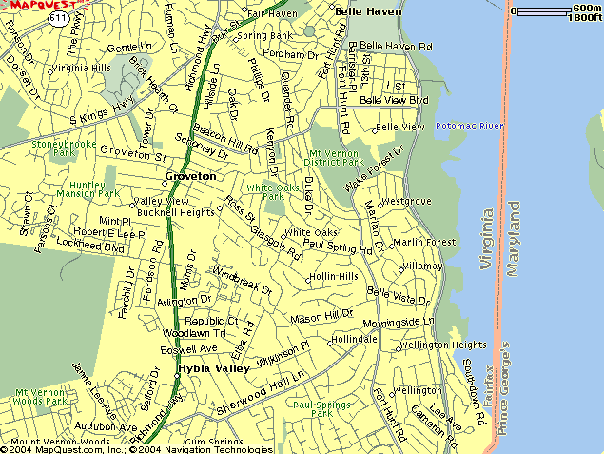
Ample off-site parking on Belle Haven Road
Start & Finish at Belle Haven Park

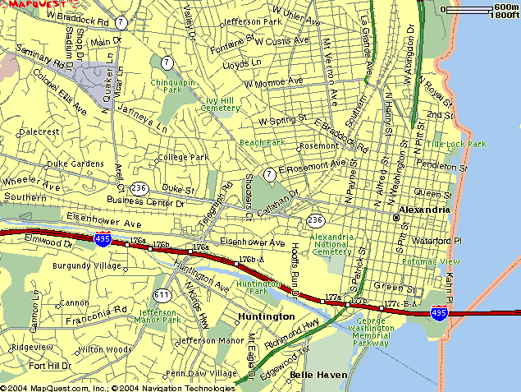
Off-site parking on Belle View Road
at Belle View Shopping Center

Spirit Stations with water, Gatorade, & first aid
at 5 locations:
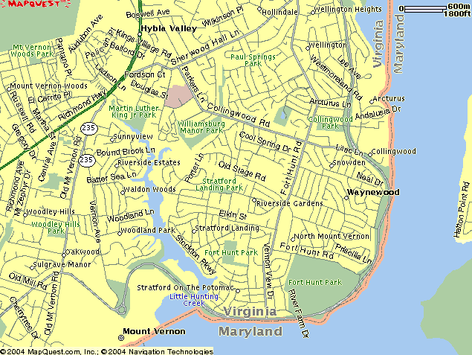
- Tulane Drive . . . . . . . . . . . . . . . . . . . . . . . .
- Alexandria Avenue (stone bridge). . . . . . . .
- Collingwood Road . . . . . . . . . . . . . . . . . . . .
- Fort Hunt Park . . . . . . . . . . . . . . . . . . . . .
- Riverside Park** . . . . . . . . . . . . . . . . . . . .
** Toilets available

Also, Spirit Stations at Wellington & Waynewood

Spectator views: Morningside, Lucia Lane, & Vernon View

Best parking and spectator view:
At the turnaround at Riverside Park
CERTIFIED COURSE MAP by ROBERT THURSTON
